Homework 2

Problem 2.9

${}_{B}^{A}T= {}_{C}^{A}T {}_{B}^{C}T$ (represented by T3, T1, T2, respectively)

Other formulas are shown in MATLAB code.

Calculations shown in MATLAB code:

Transformation matrix function:

Rotation matrix function (from transformation matrix):

Rotation axis and angle function:

MATLAB script to compute rotation axis and angle:

(Next page)

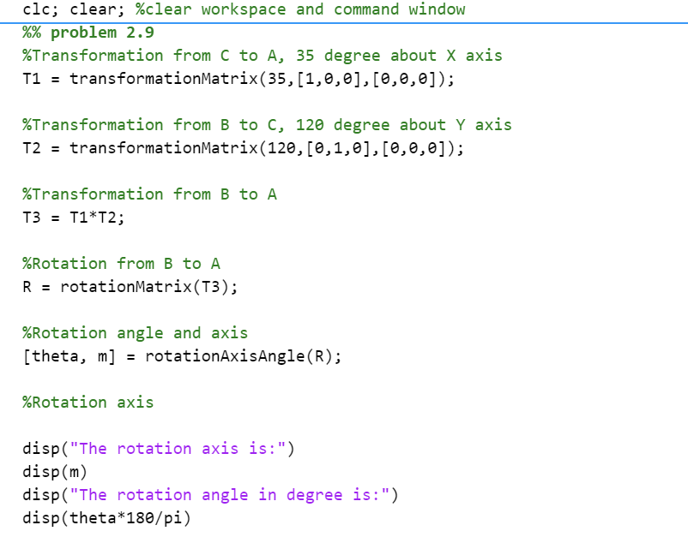

Output:

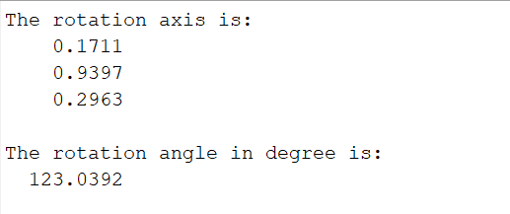

Problem 2.10 and 2.11 are not required, because my choice of programming tool is MATLAB.

Problem 3.4

(Next page)

**S3**

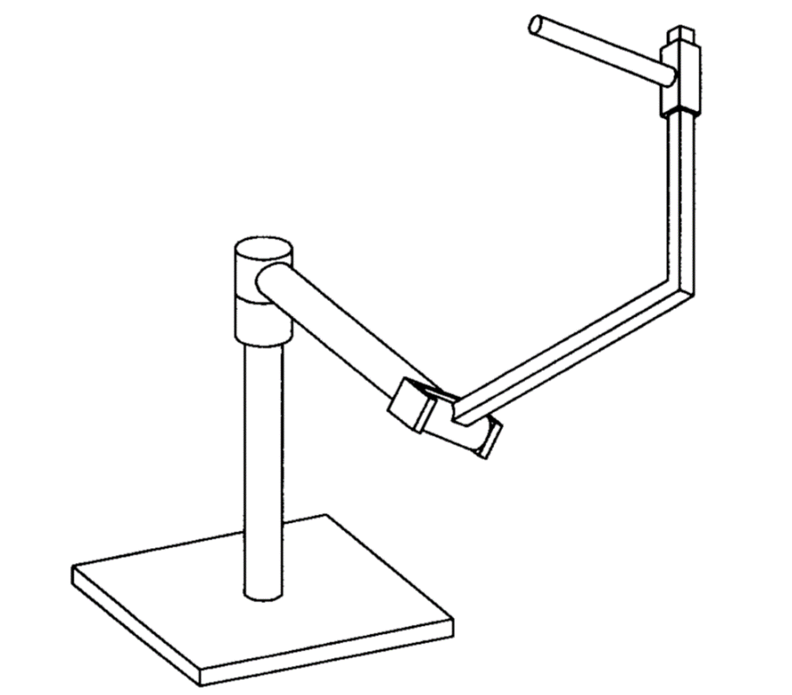

**α23**

**θ2**

**a12**

**θ3**

**S2**

**α12**

**a23**

**φ1**

**XF**

**YF**

**ZF**

**a34**

**S1**

Variable parameters: **φ1, θ2, S3**